Lesson 3 Demo 9: Pull and Delete an Image

This section will guide you to:

* Pull an image in Docker
* Delete an image in Docker

**Step 1:** Pull the *ubuntu:14.04* image from Docker Hub using the following command:

*sudo docker pull ubuntu:14.04*

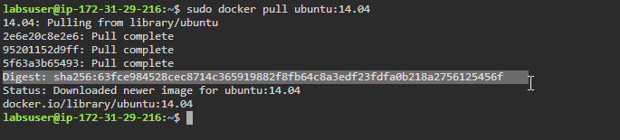

**Step 2:** Pull an *ubuntu* image using the *Digest:*

*sudo docker pull ubuntu@DIGEST*

***Note:*** *Replace DIGEST with the Digest Id of newly pulled ubuntu image in the previous step.*

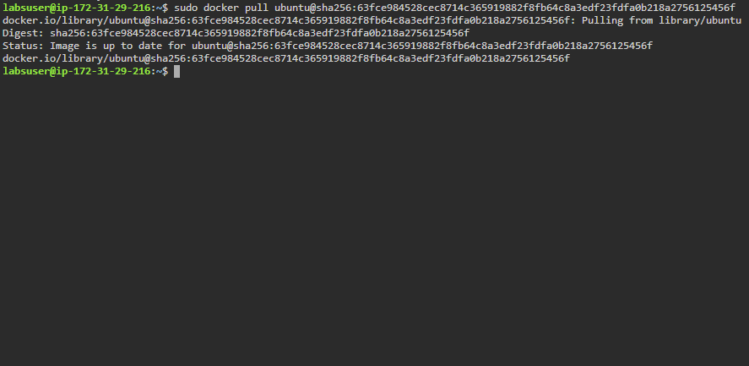

**Step 3:** Tag the image so that it points to your registry using the command:

*sudo docker image tag ubuntu:14.04 localhost:5000/ubuntu_image*



**Step 4:** Push the image to your registry using the command:

*sudo docker push localhost:5000/ubuntu_image*

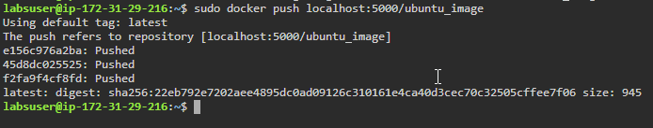

**Note**: In case of an error, run code ***docker run -d -p 5000:5000 --restart=always --name registry registry:2***

**Step 5:** Pull the image from the repository using the command:

*sudo docker pull localhost:5000/ubuntu_image*

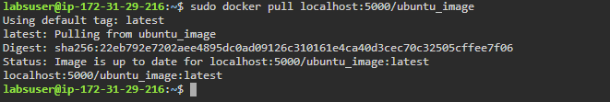

**Step 6:** Find all the images present using the command:

*sudo docker images*

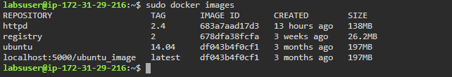

**Step 7:** Delete all Docker images using the following command:

*sudo docker rmi -f $(docker images -q)*

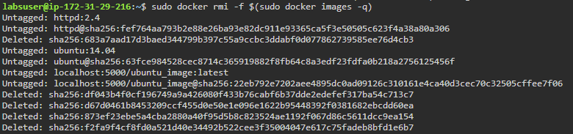

**Note:** In case of errors, stop all Docker containers and then delete using the command mentioned above.